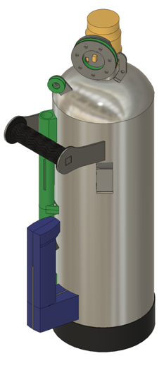
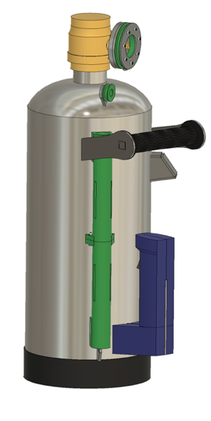
Potato launcher instructions for assembly

Preferred order:
- Outlet (threaded nipple)
- Primary spring anchor
- Forward handle
- Valve body
- Primary spring pully 1
- Inlet body, position undetermined, ask me
- Rear handle center plate

Take caution: anything made of plastic will melt at 475°F which doesn’t take very long to reach. At the same time, boiling plastic gas is inert.

Preference: don’t quench joints unless there is something melting or on fire as doing so compromises weld and material strength.

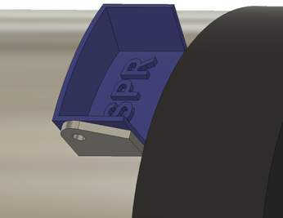
Alignment jigs are straight forward. They should have the same radius as the tank and one edge will align with the part and the other should be centered on the weld/seam of the tank which will be the centerline of the entire project. The jig for the rear handle though does not follow the centerline rule though of course since the plate itself will be on top of the seam.

Forward handle build
- Void quench rule as TPU plastic has low melting point
- It may be easier to cut the square shaft connecting the two risers oversize since the joint will be ground flush anyways
- In regard to the lateral placement, if the distance from the top of the tank conflicts with the technical drawing, disregard the drawing

Primary spring system
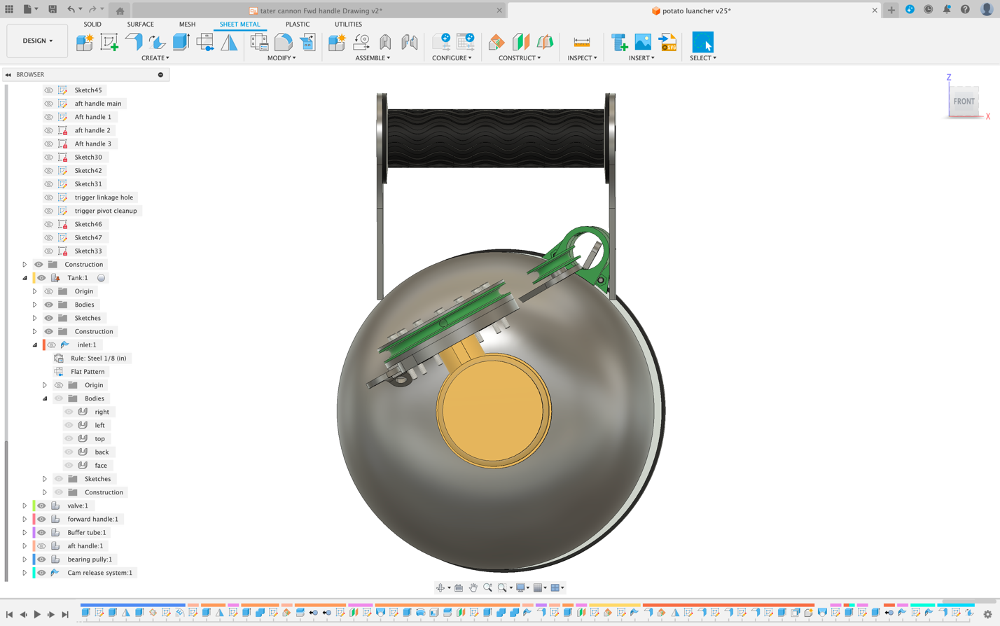
- When attaching pulleys related to the spring (trigger cam, pully 1) be sure that they are not only parallel but also that the center line that passes through them also passes through the main spring anchor
- The arm for Primary spring pully 1 is oversized and will need to be cut to length

